RESOLUTION NO.__________

RE: CERTIFICATE OF APPROPRIATENESS UNDER THE
PROVISIONS OF THE ACT OF THE PENNSYLVANIA
LEGISLATURE 1961, JUNE 13, P.L. 282 (53
SECTION 8004) AND BETHLEHEM ORDINANCE NO.
3952 AS AMENDED.

WHEREAS, it is proposed to install new signage in the display window at 701 E. Fourth Street.

NOW, THEREFORE, BE IT RESOLVED by the Council of the City of Bethlehem that a Certificate of Appropriateness is hereby granted for the work.

Sponsored by: (s)

(s)

ADOPTED BY COUNCIL THIS DAY OF

(s)
President of Council

ATTEST:

(s)
City Clerk

HISTORIC CONSERVATION COMMISSION

CASE # 529– It is proposed to install new signage in the display window at 701 E. Fourth Street.
OWNER/APPLICANT: Jasmine Chinese Restaurant / Mei Juan Chen

The Commission upon motion by Mr. Lader seconded by Mr. Cornish adopted the proposal that City Council issue a Certificate of Appropriateness for the proposed work described herein:

- The proposal to retain signage already installed on the front of the building and in windows at 701 E. Fourth Street was presented by Mei Juan Chen.

- The existing vinyl signs in the transom and display window will be removed because they are not historically appropriate and exceed zoning requirements for size of signs.

- New vinyl signage will be installed as per sketch by the Historic Office approved at the HCC meeting.

- The new sign will be red in color and the size will be reduced as shown in the sketch.
- There will be no signage in the transom glass above the display window.
- The handrail and tile base installed without HCC review were tabled for a site visit by the Historic Officer and a sketch showing modifications to make the installations more historically appropriate.

- The proposed motion was unanimously approved.

CU: cu
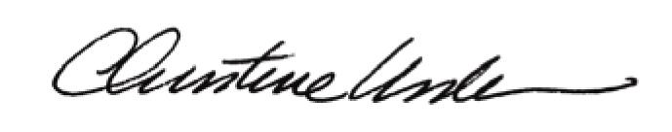

By:

Date of Meeting: February 18, 2015 Title: Historic Officer

